Supplementary Material :

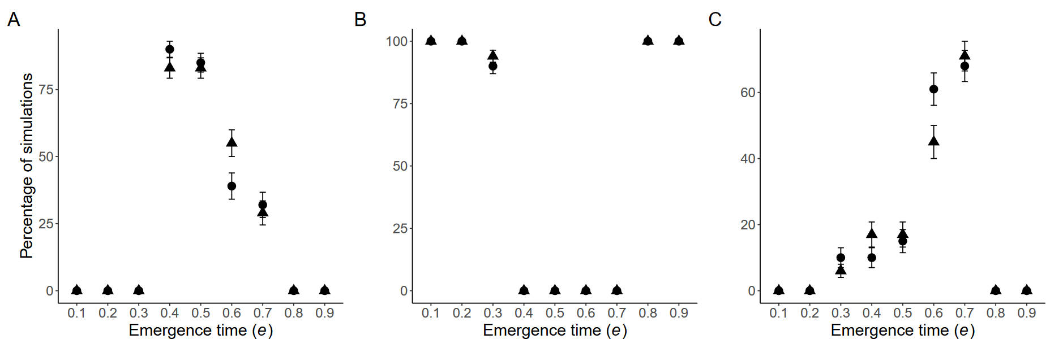

Figure S1: **Comparisons of simulation outcomes, after 500 *vs.* 2000 generations.** Circles and triangles indicate simulation outcomes after 500 and 2000 generations respectively. We run 100 simulations per condition, and distinguished them based on the distribution of the timing of reproductive activity ha after 500 generations. These distributions were either bimodal (A), late (B) or early (C). We observe similar patterns no matter the simulation length, we thus used 500-generations outcomes for all analyses in this study. Error bars represented by one standard deviation (SD). All simulations were run assuming the same parameter values: δc = 0.1, β = 3, G = 1, e = 0.5, Ve = 0.05, p = 1, K=1000.

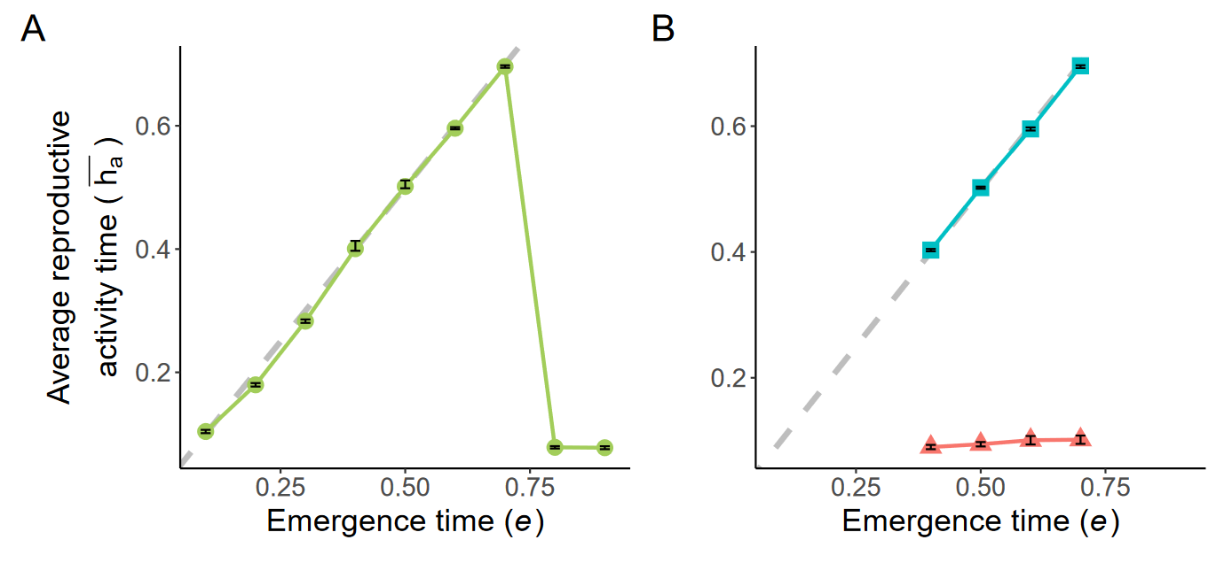

Figure S2: **Temporal niches in the sub-populations, depending on the timing of adult emergence**, estimated by the average reproductive activity timings, obtained in simulations assuming different values of the timing of emergence of adult *e*. We run 100 simulations per condition, and distinguished them based on the distribution of the timing of reproductive activity ha after 500 generations. These distributions were either unimodal (A) or a bimodal (B). In the bimodal case, *early* and *late* temporal niches can be observed, where the average ha within the sub-populations are shown in red triangles and blue squares respectively. Dashed lines then show the emergence time *e* in the corresponding simulations. Error bars represented by one SD. All simulations were run assuming the same parameter values: δc = 0.1, β = 3, G = 1, Ve = 0.05, p = 1, K=1000.

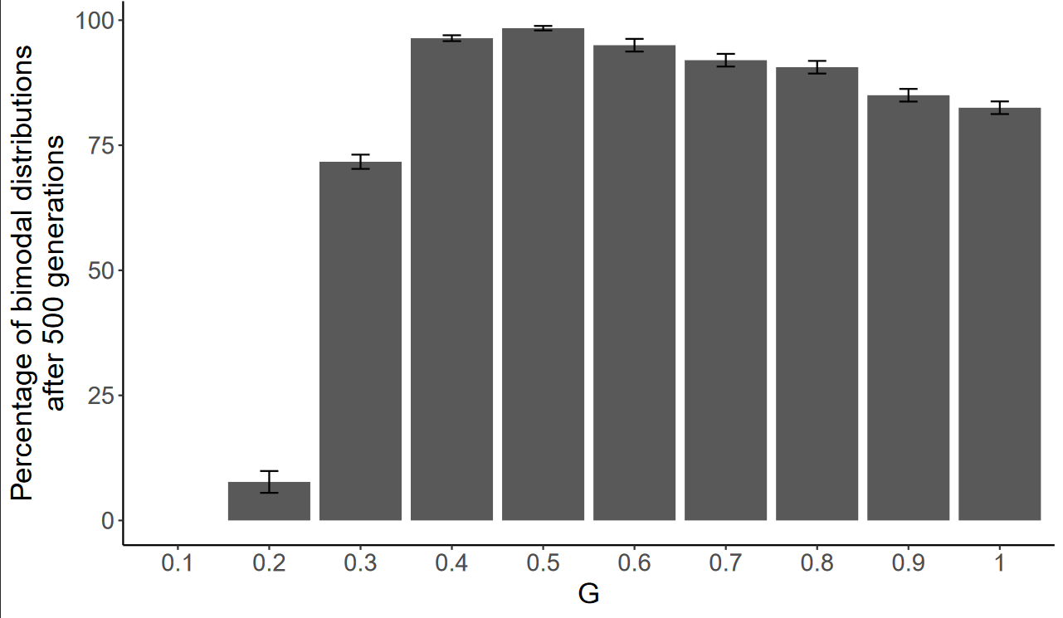

Figure S3: **Effect of the proportion of loci required to generate incompatibility (*G*) between individuals on the evolution of sub-populations with different temporal niches.** Percentage of simulations where a bimodal distribution in the timing of activities is observed at 500 generations, depending on the proportion of loci *G* necessary to trigger incompatibility. Error bars are one SD. All simulations were run assuming the same parameter values: δc = 0.1, β = 3, e = 0.5, Ve = 0.05, p = 1, K=1000.

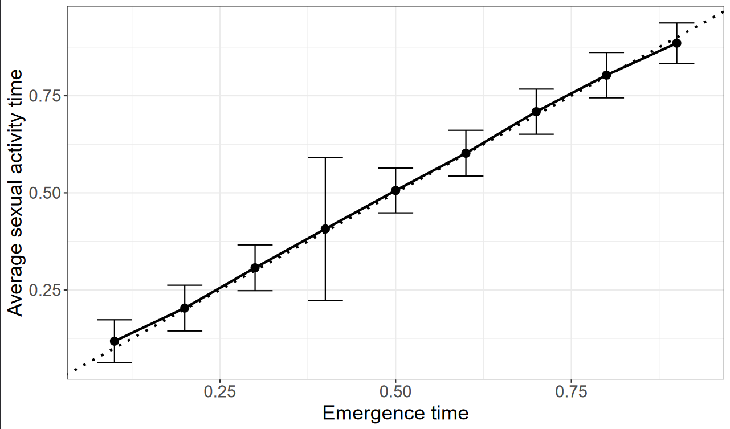Figure S4: **Effect of the emergence time *e* on the average timing of reproductive activities in a *seasonal* model (*i.e.* assuming non-overlapping generations).** The dotted line shows the emergence timing. In the *seasonal* model, average activity times are centered around the time of emergence, and no bimodality is observed in the timing of reproductive activities, assuming low level of male-male competition. Error bars are a 95% confidence interval. All simulations were run assuming the same parameter values: δc = 0 .1, β = 3, G = 0.4, Ve = 0.05, p = 1, K=1000.

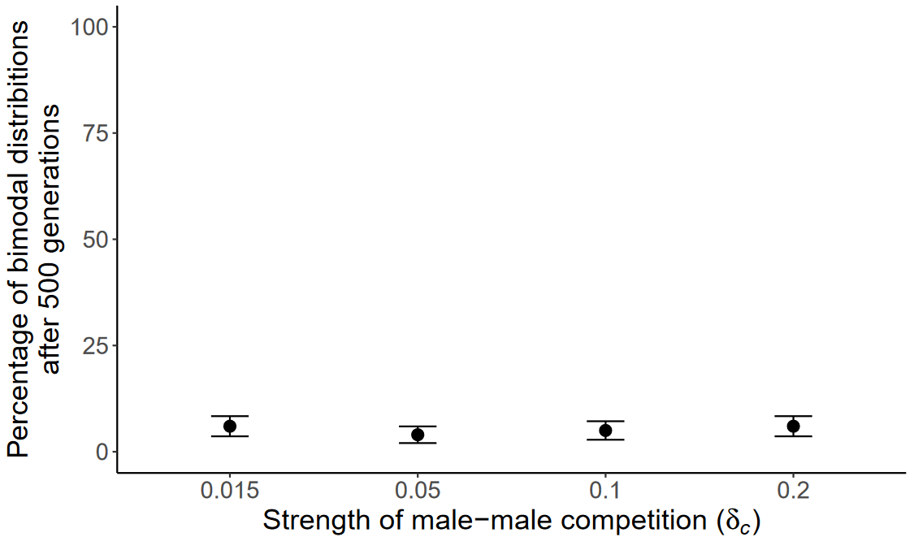Figure S5: **Effect of low levels of male-male competition on the emergence of bimodal distribution in the activity time, in a *seasonal* model.** We can observe that male-male competition values generating bi-modal distribution of reproductive activities on the *daily* model (see Figure 3B) barely produces any bimodal distribution in the activity timings in the *seasonal* model. Evolution of differentiated temporal niches indeed only happened in *circa* 5% of the simulations. Error bars are one SD. All simulations were run assuming the same parameter values: β = 3, G = 0.4, e = 0.5, Ve = 0.05, p = 1, K=1000.

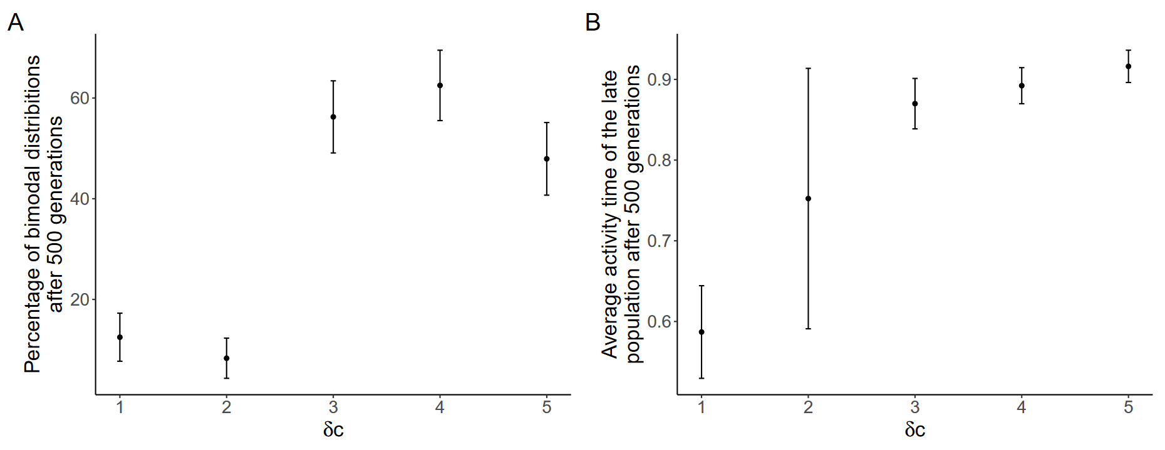

Figure S6: **Effect of male-male competition on the evolution of differentiated sub-populations in a *seasonal* model**. We run 100 simulations per condition, and distinguished them based on the distribution of the timing of reproductive activity ha after 500 generations. (A) Percentage of differentiated populations observed depending on the cost of male-male competition δc. High male-male competition can still produce frequent bimodality in the activity timings in a *seasonal* model, but only for extremes values of δc. (B) Temporal position of the *late* sub-population in the *seasonal* model depending on the cost of male-male competition δc. We can observe that higher cost for male-male competition is correlated with later and later timings of activity for *late* sub-populations. Error bars are one SD. All simulations were run assuming the same parameter values: β = 3, G = 0.4, e = 0.5, Ve = 0.05, p = 1, K=1000.